

**Artificial Intelligence and Data Science Department DBMS /Odd Sem 2024-25/Experiment 10**

|  |  |  |
| --- | --- | --- |
| **Name :Aakash Borji** | **Class/Roll No.:D6ADA/8** | **Grade :** |

# Title of Experiment

* Experiment to study DCL and TCL

# Objective of Experiment :

* 1. Understand the Concepts of DCL and TCL: To explore the fundamental concepts of Data Control Language and Transaction Control Language, including the commands associated with each.
  2. Demonstrate the Use of DCL Commands: To implement and analyze the effect of DCL commands like GRANT and REVOKE in controlling database access and permissions.
  3. Explore Transaction Management with TCL: To experiment with Transaction Control Language commands like COMMIT, ROLLBACK, and SAVEPOINT, and understand how they maintain database consistency during transactions.



**Artificial Intelligence and Data Science Department DBMS /Odd Sem 2024-25/Experiment 10**

# Description / Theory :

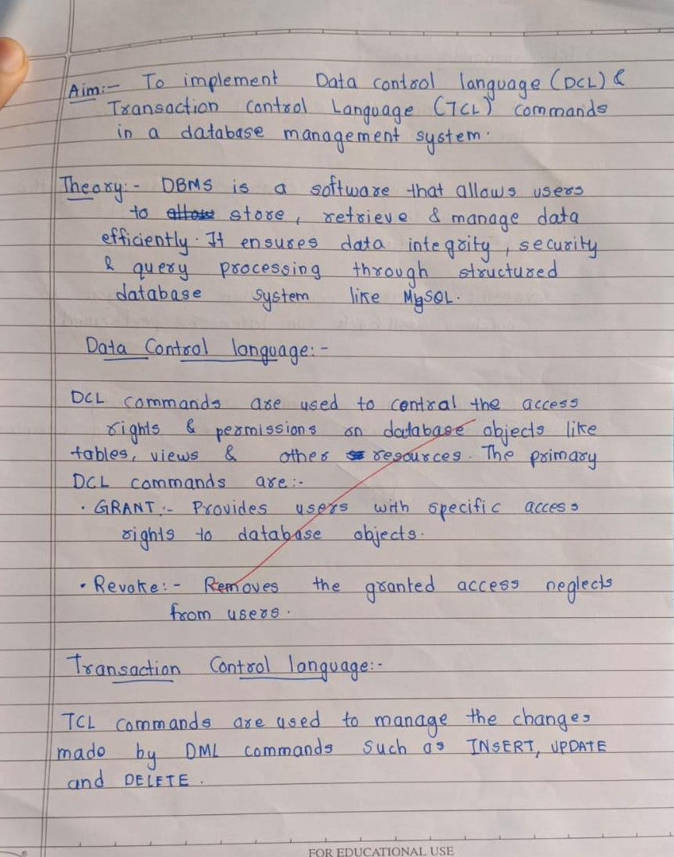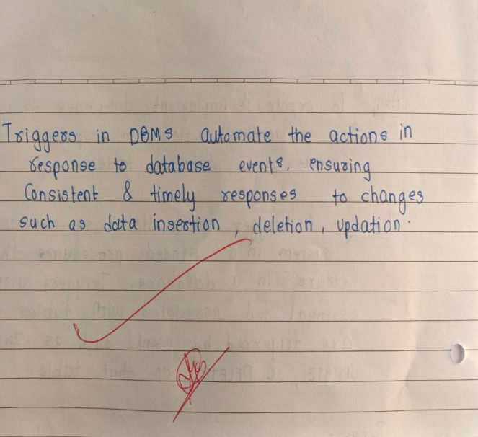



**Artificial Intelligence and Data Science Department DBMS /Odd Sem 2024-25/Experiment 10**

# Output:

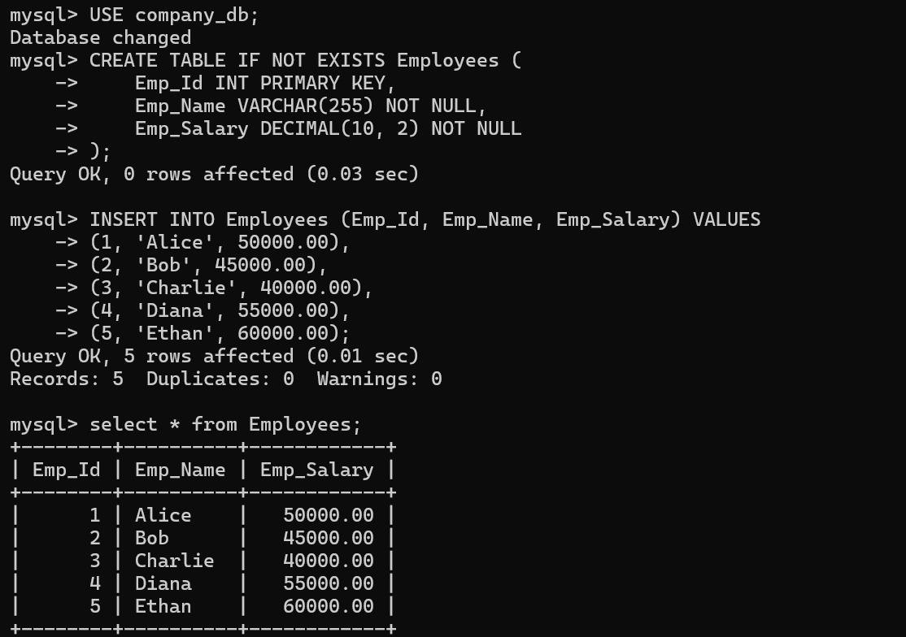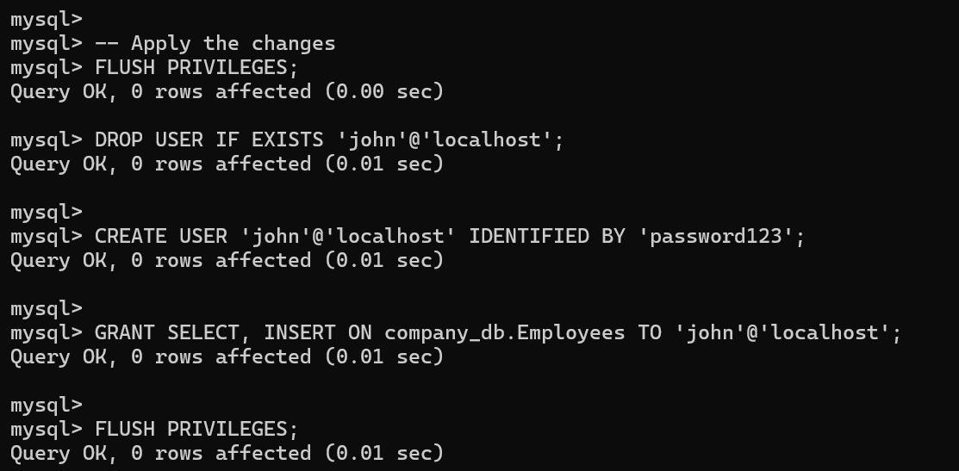

**Artificial Intelligence and Data Science Department**

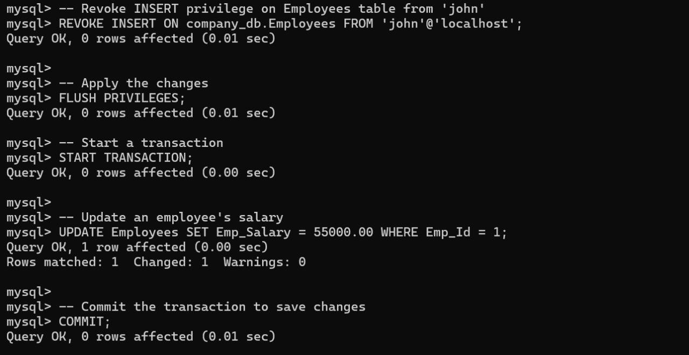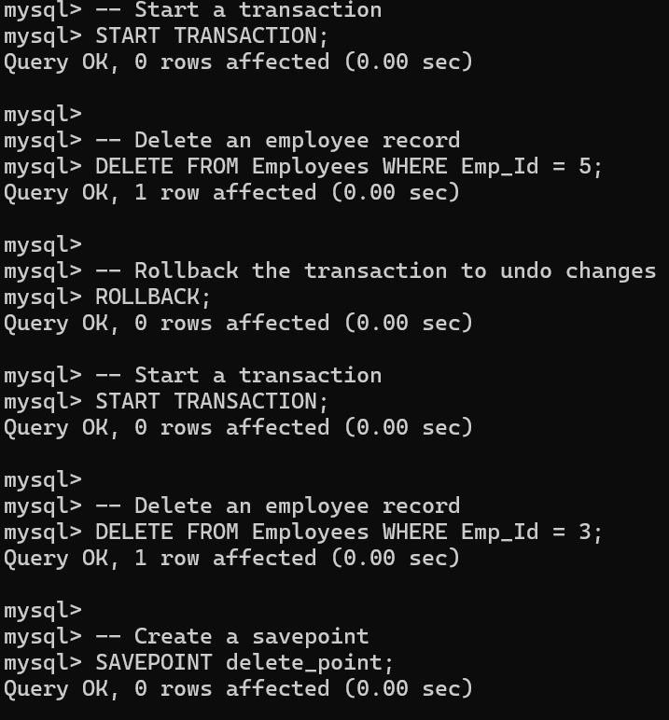

# Output

**DBMS /Odd Sem 2024-25/Experiment 10**



**Artificial Intelligence and Data Science Department**

# Output

**DBMS /Odd Sem 2024-25/Experiment 10**

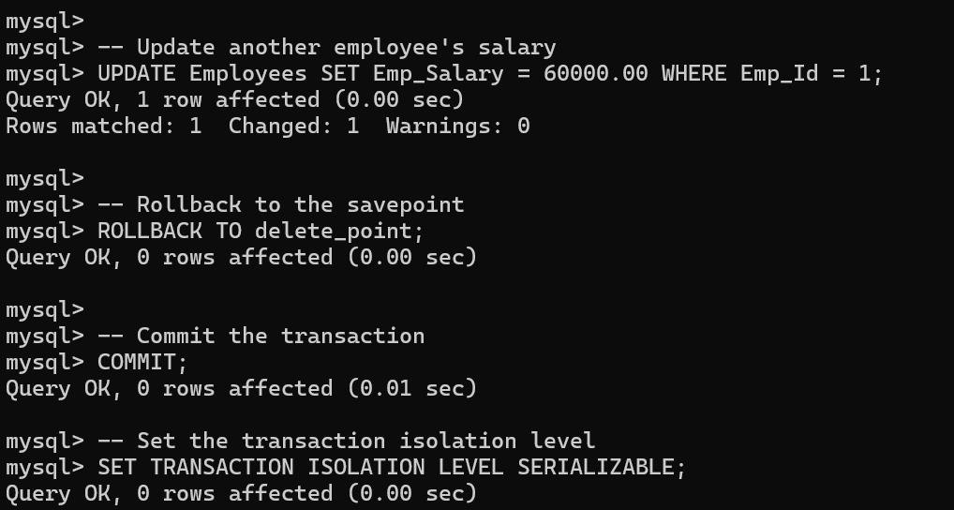



**Artificial Intelligence and Data Science Department DBMS /Odd Sem 2024-25/Experiment 10**